Data Operations - Cleaning / Preprocessing

Definition
# Source: AI Source: Provided by: [Data Path: Persons Table -> ID Column: 1, Name_En Column: Motasem Essam] -> From: [Chatgpt (GPT‑5 Mini)] on [12/10/2025]
Data Cleaning / Preprocessing is the process of preparing raw data for analysis by detecting and correcting errors, inconsistencies, or missing values.
- It improves data quality, accuracy, and reliability before performing analysis.
- Raw data is often incomplete, noisy, or inconsistent, so preprocessing is necessary to make it usable.

Key idea:
# Source: AI Source: Provided by: [Data Path: Persons Table -> ID Column: 1, Name_En Column: Motasem Essam] -> From: [Chatgpt (GPT‑5 Mini)] on [12/10/2025]
It is like editing and organizing information before using it, ensuring the data is correct and consistent.

Characteristics of Data Cleaning / Preprocessing
# Source: AI Source: Provided by: [Data Path: Persons Table -> ID Column: 1, Name_En Column: Motasem Essam] -> From: [Chatgpt (GPT‑5 Mini)] on [12/10/2025]
- Removes incorrect, duplicate, or irrelevant data
- Handles missing values or incomplete records
- Corrects format inconsistencies (dates, text, numbers)
- Standardizes data for consistent analysis
- Often performed before sorting, filtering, and analysis

Common Data Cleaning Techniques

1. Removing Duplicates
# Source: AI Source: Provided by: [Data Path: Persons Table -> ID Column: 1, Name_En Column: Motasem Essam] -> From: [Chatgpt (GPT‑5 Mini)] on [12/10/2025]
Duplicate records are identified and removed to avoid incorrect analysis.
Example:
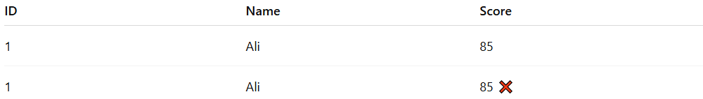
ID | Name | Score
1 | Ali | 85
1 | Ali | 85 ❌
The duplicate record is removed to maintain accurate data.

2. Handling Missing Data
# Source: AI Source: Provided by: [Data Path: Persons Table -> ID Column: 1, Name_En Column: Motasem Essam] -> From: [Chatgpt (GPT‑5 Mini)] on [12/10/2025]
Missing values are either filled, replaced, or removed.
Example:
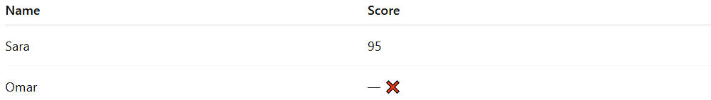
Name | Score
Sara | 95
Omar | — ❌
Possible solutions:
- Fill with average score
- Replace with estimated value
- Remove the record

3. Correcting Data Formats
# Source: AI Source: Provided by: [Data Path: Persons Table -> ID Column: 1, Name_En Column: Motasem Essam] -> From: [Chatgpt (GPT‑5 Mini)] on [12/10/2025]
Data is converted into a consistent format.
Example:
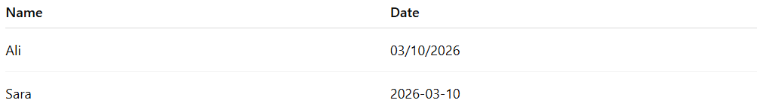
Name | Date
Ali | 03/10/2026
Sara | 2026-03-10
After cleaning:
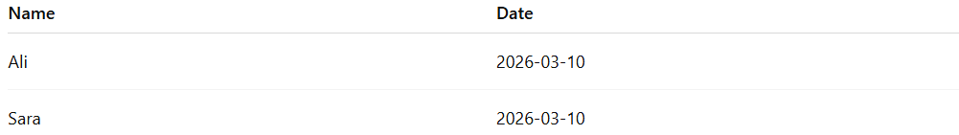
Name | Date
Ali | 2026-03-10
Sara | 2026-03-10

4. Removing Outliers
# Source: AI Source: Provided by: [Data Path: Persons Table -> ID Column: 1, Name_En Column: Motasem Essam] -> From: [Chatgpt (GPT‑5 Mini)] on [12/10/2025]
Extreme or unrealistic values are identified and corrected or removed.
Example:
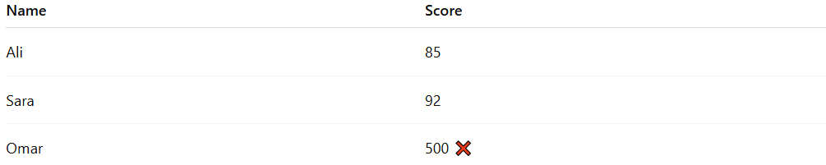
Name | Score
Ali | 85
Sara | 92
Omar | 500 ❌
A score of 500 is unrealistic and flagged as an outlier.

5. Standardizing Data
# Source: AI Source: Provided by: [Data Path: Persons Table -> ID Column: 1, Name_En Column: Motasem Essam] -> From: [Chatgpt (GPT‑5 Mini)] on [12/10/2025]
Different versions of the same value are unified.
Example:
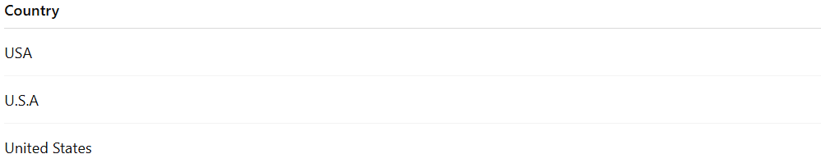
Country
USA
U.S.A
United States
After standardization:
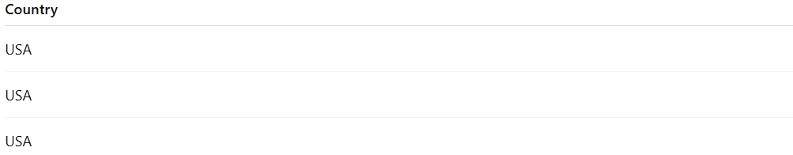
Country
USA
USA
USA

Example Section
# Source: AI Source: Provided by: [Data Path: Persons Table -> ID Column: 1, Name_En Column: Motasem Essam] -> From: [Chatgpt (GPT‑5 Mini)] on [12/10/2025]
A student dataset before cleaning:
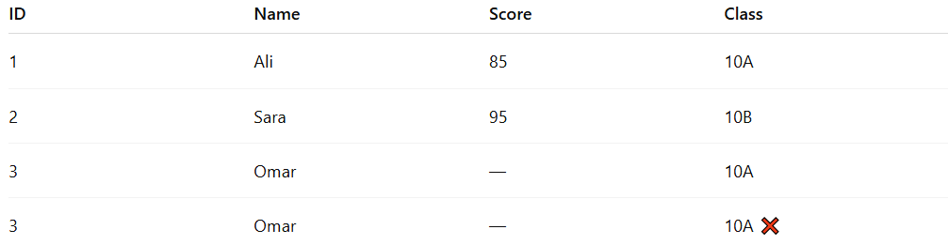
ID | Name | Score | Class
1 | Ali | 85 | 10A
2 | Sara | 95 | 10B
3 | Omar | — | 10A
3 | Omar | — | 10A ❌
Cleaning steps:
- Remove duplicate record
- Fill missing score for Omar
- Ensure consistent data format
Cleaned dataset:
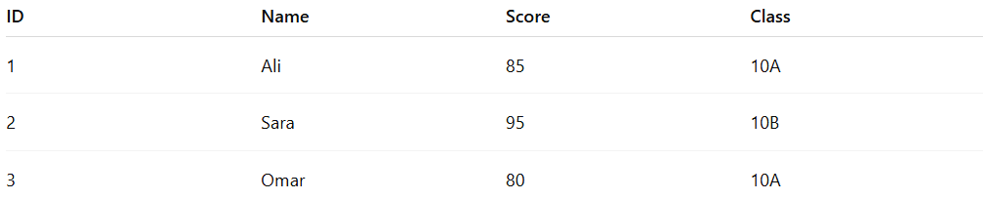
ID | Name | Score | Class
1 | Ali | 85 | 10A
2 | Sara | 95 | 10B
3 | Omar | 80 | 10A

Advantages
# Source: AI Source: Provided by: [Data Path: Persons Table -> ID Column: 1, Name_En Column: Motasem Essam] -> From: [Chatgpt (GPT‑5 Mini)] on [12/10/2025]
- Improves data accuracy and quality
- Reduces errors in analysis and reporting
- Makes datasets consistent and reliable
- Helps produce better insights and decisions

Disadvantages
# Source: AI Source: Provided by: [Data Path: Persons Table -> ID Column: 1, Name_En Column: Motasem Essam] -> From: [Chatgpt (GPT‑5 Mini)] on [12/10/2025]
- Can be time-consuming for large datasets
- Requires expert knowledge to identify errors correctly
- Over-cleaning may remove useful or important data
- Some missing or incorrect data cannot always be recovered

Standardizing Data vs Correcting Data Formats

Correcting Data Formats
# Source: AI Source: Provided by: [Data Path: Persons Table -> ID Column: 1, Name_En Column: Motasem Essam] -> From: [Chatgpt (GPT‑5 Mini)] on [12/10/2025]
- Focus: Fix errors in how the data is recorded.
- Example: Changing a date like 14/03/26 → 2026-03-14 because it was written inconsistently.
- Goal: Make the format valid and consistent for the system to understand.
- Usually happens before analysis.

Standardizing Data
# Source: AI Source: Provided by: [Data Path: Persons Table -> ID Column: 1, Name_En Column: Motasem Essam] -> From: [Chatgpt (GPT‑5 Mini)] on [12/10/2025]
- Focus: Make data uniform across the dataset so it’s comparable.
- Example:
  - Convert all weights to kilograms (150 lbs → 68 kg)
  - Normalize gender labels: M, m, Male → Male
  - Ensure consistent naming conventions: NYC, New York → New York
- Goal: Ensure all similar data points follow the same standard.

Key Difference
# Source: AI Source: Provided by: [Data Path: Persons Table -> ID Column: 1, Name_En Column: Motasem Essam] -> From: [Chatgpt (GPT‑5 Mini)] on [12/10/2025]
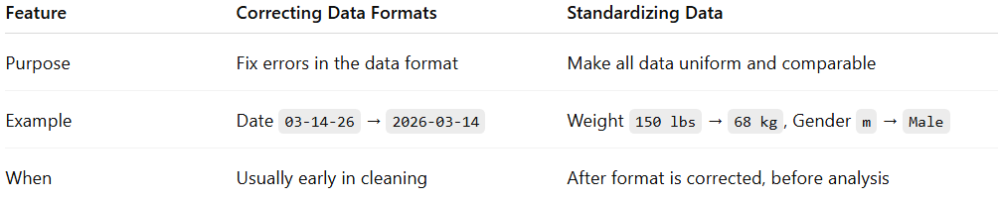
Feature | Correcting Data Formats | Standardizing Data
Purpose | Fix errors in the data format | Make all data uniform and comparable
Example | Date 03-14-26 → 2026-03-14 | Weight 150 lbs → 68 kg, Gender m → Male
When | Usually early in cleaning | After format is corrected, before analysis

✅ Summary:
# Source: AI Source: Provided by: [Data Path: Persons Table -> ID Column: 1, Name_En Column: Motasem Essam] -> From: [Chatgpt (GPT‑5 Mini)] on [12/10/2025]
- Correcting formats ensures data is readable and valid.
- Standardizing ensures data is consistent across the dataset so analysis is meaningful.

